Project Report

on
Query Implmentation using B+Trees

Submitted for the partial fulfillment of the Requirements for
the awarding of the Degree of

MASTER OF COMPUTER APPLICATIONS

By

Allam Narendra
(Regd.No: 04021F0017)

Under the esteemed guidance of

Internal Guide Head of the Department
Dr.JVR Murthy Dr.JVR Murthy
Head of the Department , Computer science
Computer science J.N.T.U.College of Engineering
J.N.T.U.College of Engineering Kakinada. Kakinada.

Department of Computer Science and Engineering
JAWAHARLAL NEHRU TECHNOLOGICAL UNIVERSITY
College of Engineering, KAKINADA-533 003
2004-2007

JAWAHARLAL NEHRU TECHNOLOGICAL UNIVERSITY

COLLEGE OF ENGINEERING
KAKINADA-533003

CERTIFICATE

This is to certify that the project work entitled “Query Implemenation using B+Trees” is a bonafide work done by Mr. Allam Narendra bearing Roll No: 04021F0017 in partial fulfilment of requirements for the award of the degree of Master of Computer Applications (MCA) during 2004-07.

This project work is not submitted to any University for the award of any degree/diploma..

(Internal Guide) (Head of the Department)

Dr. J.V.R.Murthy, Dr. J.V.R.Murthy,
Head of the Department, Head of the Department,
Department of CSE, Department of CSE,
J.N.T.U.C.E, Kakinada J.N.T.U.C.E, Kakinada

ACKNOWLEDGEMENT

I am extremely thankful to Dr. J.V.R.Murthy, Head of the Department, Computer Science and Engineering, JNTU College of Engineering, Kakinada, for extending his co-operation, suggestions and keenness in the subject throughout the course of M.C.A.

I am very thankful to Mr. B.Sateesh Kumar, Assistant Professor, Department of Computer Science and Engineering, JNTU College of Engineering, Kakinada for his timely help, suggestions and guidance

-Allam Narendra

ABSTRACT

PROJECT TITLE:

QUERY IMPLEMENTATION USING B+ TREE.

Tools used:

g++ (C++ Compiler) and Red Hat Enterprise LINUX.

Gdb (GNU Debugger)

Electric Fence (A Virtual Memory Protector)

DESCRIPTION:

We are developing Query operations LESS THAN, GREATER THAN and EQUAL TO on very large amount of data records (Key-Value Pairs) for very efficient processing using B+Tree Data Structure and Multi threading using C++ on LINUX.

B+ Tree- The Most Widely Used Index.

Main characteristics:
- For a n-order B+ tree with a height of h:
- maximum number of keys is n^{h}
- Minimum number of keys is 2(n / 2)^{h − 1}.

INDEX

- INTRODUCTION
- OBJECTIVES
- SYSTEM REQUIREMENT SPECIFICATION
3.1 SOFTWARE AND HARDWARE REQUIREMENTS
4. LITERATURE SURVEY
4.1 ACRONYMS AND ABBREVIATIONS USED IN THIS PROJECT
4.2 ABOUT Gcc
4.3 ABOUT Gdb
- DATA FLOW DIAGRAMS
- TESTING.
5.1 TESTING METHODS
  - WHITE BOX TESTING
  - BLACK BOX TESTING
- IMPLEMENTATION
- SAMPLE SREENS
- CONCLUSION.
- BIBILOGRAPHY.

Query Implementation using B+ Trees

- Characteristics of the B+ Tree:

  - It can be capable of holding one million elements
  - It max 100 accesses to fetch an element
  - Develop queries for =, <, > and for Updating
  - Use Multiprocessing or threading
  - Use g++ on Linux

- What is B+Tree:

• A dynamic index structure that adjusts gracefully to inserts and deletes
• A balanced tree
• Leaf pages are not allocated sequentially. They are linked together through pointers and linked list

- In computer science, a B+ tree is a type of tree data structure. It represents sorted data in a way that allows for efficient insertion and removal of elements. It is a dynamic, multilevel index with maximum and minimum bounds on the number of keys in each node. The NTFS file system for Microsoft Windows uses this type of tree.
- A B+ tree is a variation on a B-tree. In a B+ tree, in contrast to a B-tree, all data is saved in the leaves. Internal nodes contain only keys and tree pointers. All leaves are at the same lowest level. Leaf nodes are also linked together as a linked list to make range queries easy.
- The maximum number of pointers in a record is called the order of the B+ tree.
- The minimum number of keys per record is 1/2 of the maximum number of keys. For example, if the order of a B+ tree is n+1, each node (except for the root) must have between (n+1)/2 and n keys. If n is an even number the minimum number of keys can be either (n/2)-0.5 or (n/2)+0.5 but it must be the same in the whole tree.
- The number of keys that may be indexed using a B+ tree is a function of the order of the tree and its height.
- For a n-order B+ tree with a height of h:
- maximum number of keys is n^{h}
- Minimum number of keys is 2(n / 2)^{h − 1}.

B+Tree 0f order 4
3
4
5
10
11
15
20
30
40
5
15
40
“John”
“kiran”
“srikanth”
“Raju”
“Priyanka”
“sridhar”
“Arun”
“Sneha”
“karthik”
o
50
60
70
“sunitha”
“Ram”
“Anu”
Root
2000
5000
7000
1000
4000

To insert a new value:
- Follow the pointers down ntil you find where it should be in the leaf node.
- If the leaf node has space, just insert the value and appropriate record pointer.
- If the node is full (has n values), you must split the node into 2 nodes.
a. Insert the new value in the correct order.
b. Split the old leaf node into 2 new nodes, with half (or half + 1) the values in each node.
c. Adjust the old leaf node's parent index node to reflect the change by inserting a new index value and pointers. Insert the last value in the new left-hand node in the appropriate place in the parent node. If the parent node still has space, this is easy, but note that the split could propagate up the tree. If so, remember that a value occurs at most once in the index structure. When you split an index node, bump the middle value up into the next level, rather than copying it.

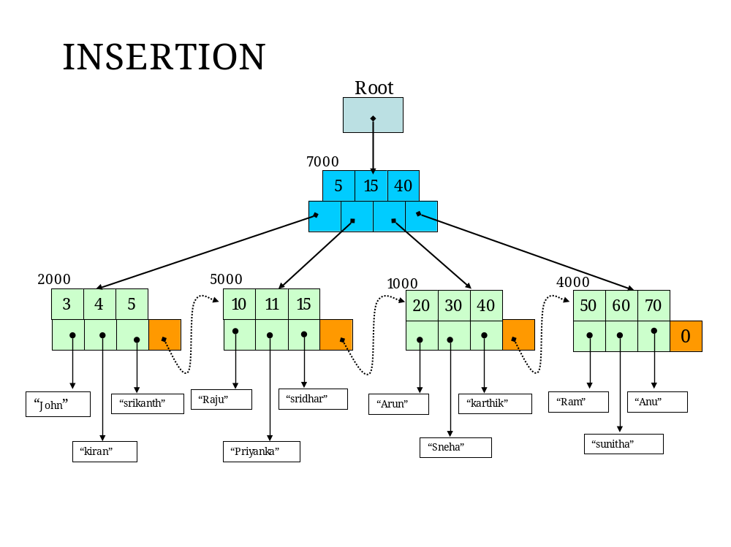

11
6000
Key 11 and address 6000 will be pushed to upper level
3
4
5
10
11
20
30
40
5
15
40
“John”
“kiran”
“srikanth”
“Raju”
“Priyanka”
“Arun”
“Sneha”
“karthik”
0
50
60
70
“sunitha”
“Ram”
“Anu”
Root
12
15
Node splitting
2000
5000
7000
1000
4000
New node
6000
“sridhar”
“Ratan”

15
40
3
4
5
10
11
20
30
40
5
11
“John”
“kiran”
“srikanth”
“Raju”
“Priyanka”
“Arun”
“Sneha”
“karthik”
50
60
70
“sunitha”
“Ram”
“Anu”
Root
12
15
2000
5000
7000
1000
4000
6000
“sridhar”
“Ratan”
Node splitting
4000
New node
11
4000

15
40
After Insertion of 12
3
4
5
10
11
20
30
40
5
11
“John”
“kiran”
“srikanth”
“Raju”
“Priyanka”
“Arun”
“Sneha”
“karthik”
50
60
70
“sunitha”
“Ram”
“Anu”
Root
12
15
2000
5000
7000
1000
4000
6000
“sridhar”
“Ratan”
New root Node
4000
11
4000
8000

11
15
40
After Insertion of 12
3
4
5
10
11
20
30
40
5
“John”
“kiran”
“srikanth”
“Raju”
“Priyanka”
“Arun”
“Sneha”
“karthik”
50
60
70
“sunitha”
“Ram”
“Anu”
Root
12
15
2000
5000
7000
1000
4000
6000
“sridhar”
“Ratan”
4000
8000

To delete a value:
- Delete the value from the leaf node, and if it appeared in one of the index nodes, delete it from there too. The only tricky part is if deleting a value causes the number of values in the node to drop below the lower threshold, then you must readjust it and its neighbouring nodes. There are 2 options:
a. If either its right or left sibling has enough values so that they can be split and still keep enough values in both nodes,
i. Redistribute the values accordingly, and
ii. Change the index value in the parent node so it is the rightmost value of the left sibling.
b. If neither sibling has enough values, merge the node with a sibling. This is the reverse of insertion.
i. Order the values in both nodes into one node, and
ii. Remove the index entry from the parent node. Note that the merge could propagate up the tree.

Software Requirements

1 | Operating System | Red Hat Linux
2 | Language | GCC COMPILERSUITE1.4.1.2
3 | Electric Fence | Electric Fence should be installed
4 | Pthread Library | POSIX threads library should be installed

Hardware Requirements

1 | System Chipset | Linux Compatibility
2 | RAM | 512MB
3 | Network | 100MBPS Internet work
4 | Hard disk Capacity | 80 GB.

ACRONYMS AND ABBREVIATIONS USED IN THIS PROJECT
Acronym | Explanation
P Thread | POSIX Thread Library(User Level Thread Library)
B-Tree | Balanced Tree
GCC | GNU C Compiler
G++ | GNU C++ Compiler
E Fence | Electric Fence Library
Sibling | Node At Equal Level

About GCC:

GCC stands for “GNU Compiler Collection”. GCC is an integrated distribution of compilers
for several major programming languages. These languages currently include C, C++,
Objective-C, Objective-C++, Java, Fortran, and Ada.
The abbreviation GCC has multiple meanings in common use. The current official meaning
is “GNU Compiler Collection”, which refers generically to the complete suite of tools.
The name historically stood for “GNU C Compiler”, and this usage is still common when
the emphasis is on compiling C programs. Finally, the name is also used when speaking
of the language-independent component of GCC: code shared among the compilers for all
supported languages.

About GDB:

It is GNU debugger, it is command line version and part of the GNU compiler kit.It has break point , stack trace etc options

B+ Tree Data Structure
1000000
Elements

Insertion
Deletion
Multi Processing
Updating

Queries

Data Flow Diagrams

The Data Flow Diagram represents the logical model of the system. The information flow is depicted in the form of Data Flow Diagrams (DFD). The DFD’s drawn into levels. Context level diagram indicates the major processes within the scope of the system. The various levels and their sub-levels represents the expansion of major processes shown in Context level diagram in greater detail to bring out the clarity of various procedures and functions.

Entity:
Another system or sub-system
that interacts with the system or
sub-system represented in the
DFD. They are also referred as he
source or the sink where data
originates or information gets
deposited.

Process:
This symbol represents
processes identified in the DFD
where data gets transformed.
This is the place where data
gets registered, stored or
transformed to information.

Data Repositories:
Indicates repositories that
store data. This data store
shall be later used for analysis
of database design.

Connector:
This symbol syndicates the
data or information flow
between entities to processes,
repositories to processes,
processes to entities or
processes to repositories or
processes to processes.

B+ Tree Data Structure
1000000
Elements
Insertion
Deletion
Updating
Other Queries
Insertion
Deletion
Updating
Other Queries
Insertion
Deletion
Updating
Other Queries
Client 1
Client 2
Client 3
Server
Server process
Forked processes

TESTING

TESTING METHODS:

Software Testing is a critical element of software quality assurance and represents the ultimate review of specification, design, and coding. Testing is the one step in software engineering process that could be viewed as destructive rather than constructive. The goal of testing is to verify the design and logical operation of the design blocks to determine that they operate as intended. A good test case is one that has a high probability of finding an as-yet undiscovered error. A successful test is one that uncovers an as-yet-undiscovered error.

TESTING OBJECTIVES:

1. Testing is a process of executing a program with the intend of finding an error.
2. A good test case is one that has a high probability of finding an as yet undiscovered error.
3. A successful test is one that uncovers as yet undiscovered error.
Testing cannot show the absence of defects, it can show that software errors are present.

TESTING PRINCIPLES:

All tests should be traceable to customer requirements.
Tests should be planned long before testing begins.
The Pareto principle applies to software testing.
Testing should begin “in the small” and progress toward testing “in the long.”
Exhaustive testing is not possible.
To be most effective, independent third party should conduct testing

TESTABILITY

Operability: “The better it works, the more efficiently it can be tested”

Observability:” What you see is what you test”

Controllability:” The better we can control the software, the more the testing can be automated and optimized”.

Decomposability: ”By controlling the scope of testing we can more quickly isolate problems and perform smarter retesting.”

Simplicity:” The less there is to test the more quickly we can test it.”

Stability:” The fewer the changes the fewer the disruptions to testing.”
Understandability:” The more information the smarter we will test.”

Testing may be done in two ways: -

- White box testing.
- Black box testing.

White box Testing:

This is a test case design method that uses the control structure of the procedural design to derive test cases. By using this test cases we can guarantee that all independent paths with in a module have been exercised atleast once.
Exercise all global decisions on their true and false sides.
Execute all loops at their boundaries and with in their operational bounds.
Exercise internal data structures to assure their validity.

The following are in the white box testing

1. UNIT TESTING:

During the implementation of the system each module of the system was tested separately to uncover errors with are its boundaries. User interfaces was used as a guide in this process.

2. FUNCTIONALITY TEST:

To ensure that each module can do intended functions and only those correctness and robustness.

3. BOUNDED CONDITIONS TEST:

Boundary conditions as in case of generating sequences were tested to ensure that the module operates properly at boundaries established to limit or restrict processing.

4. INTEGRATION TESTING:

The objective of integration testing is to take the unit tested modules and builds a program structure that has been defined in the design .we have done a top down integration which is an incremental approach that is constructing and testing small segments where errors are easier to isolate and corrected.
The integration process was performed in three steps.
- The main control was used as test driver.
- Tests were conducted as each module was integrated.
- Regression testing (that is conducting al or some of the previous tests to ensure that new errors have not been introduce

Black Box Testing:

Black Box Testing enables us to derive sets of input conditions that will fully exercise all functional requirements for a program.

Black Box Testing attempts to find errors in the following categories.

- Incorrect or missing functions
- Interface errors
- Errors in data structures or external data base access
- Performance errors
- Initialization and termination errors

By applying Black Box Techniques, we derive a set of test cases that justify the following criteria.
Test cases that reduce by a count that is greater than one , the number of additional test cases that must be designed to achieve reasonable testing
Test cases that tell us something about the presence and absence of classes of Errors, rather than errors associated only with the specific test at hand.

The different test strategies used are:

Unit testing
It focuses verification effort on the smallest unit of system design-the module.

Integration testing
Integration testing is a systematic technique for construction the program structure while conducting test to uncover errors associated with interfacing.

Validation testing
Validation succeeds when system functions in a manner that can be reasonably expected by the end user. This is achieved through a series of black-box tests that demonstrate conformity with requirements. There are two tests conducted for the system validation.

Alpha test
A customer conducts it at the developer's site. The software is used in a natural setting with the developer "looking over the shoulder" of the user and recording errors and usage problems.

Beta test
This test is conducted at one or more user sites by the end user(s) of the software. Here the developer is generally not present. Therefore, the beta test is a "live" application of the software in an environment that cannot be controlled by the developer.

System testing
System testing is actually a series of different test whose primary purpose is to fully exercise the computer-based system. During this process recovery testing is done which is a system test that forces the software to fail in a verity of ways and verifies that recover is properly performed. Security testing attempts to verify that protection mechanisms built into system will in fact protect it from improper penetration.

Implementation

System Implementation

Designing Maintainable System

In the designing software we have to tackle much care about the implementation. In the most cases developing software is very easy but when implementation issues we have to consider the important attribute of maintainability.

Maintainability is the routine process after developing the application. So should give the error less package to users so that he need not bother about the package. When developing the application we have to concentrate on the resources to be convenient for the user and his needs. This is the cost that should not cross certain limit. In the implementation we have to make the modules, which are not required. We have to make the modules to work independently as much as possible. This will reduce the failure, if one or more modules got failed.

Documentation

While developing software, when it reached the implementation stage, we should maintain the documentation. Documentation helps the end user very efficiently. He will know what is going on in a particular module.

Validation

Validation of data is more important. Validation of data should keep the application consistent, so that the output will be reliable. Training the system operators is also important we should train the operators how to use the package and how to utilize the facilities that are incorporated in the system. For this purpose we have to give demonstration on the system.
Sample Source code:
/********************************************* B+ Tree program*/
#include<stdio.h>
#include<stdlib.h>
#include<string.h>
#include<iostream.h>
//#include<conio.h>
#define MAX 4
#define MIN 2
#define Bool int
#define TRUE 1
#define FALSE 0

typedef int key_type;
enum flag_type {KEY_DATA,KEY_ONLY} ;

typedef struct Node_tag
{
enum flag_type flag;//This flag tells whether the node is having data or key only
int count;
key_type key[MAX+1];
struct Node_tag *branch[MAX+1];
}Node;

class BplusTree
{
Node * root;
public:
int ele_find;
char data_str[100];
int ncount;
BplusTree()
{
root = NULL;
ele_find=0;
ncount=0;
}
/* 1 */ Node* Search(key_type ,Node *,int *);
/* 2 */ Bool Search_node(key_type,Node *,int *);

/******************************************************************** insertion routines*/

/* 3 */ Node * Insert(key_type ,Node *);
/* 4 */ Bool Pushdown(key_type ,Node *,key_type *,Node**);
/* 5 */ void Pushin(key_type ,Node *,Node *,int );
/* 6 */ void Split(key_type ,Node *,Node *,int ,key_type *,Node **);

/********************************************************************Display routine*/

/* 7 */ void Display(Node *);
/* 8 */ void Bplus_Display(Node*);

/**********************************************************Deletion routines*/

/* 9 */ Node *Del_node(key_type ,Node *);
/* 10 */ Bool Rec_delete(key_type ,Node *);
/* 11 */ void Remove(Node*,int );
/* 12 */ void Successor(Node *,int );

/* 13 */ void Restore(Node *,int );
/* 14 */ void Move_right(Node *,int);
/* 15 */ void Move_left(Node *,int );
/* 16 */ void Combine(Node *,int );

// B+ Tree versions ************************

/* 17 */ void Bpls_Restore(Node *,int );
/* 18 */ void Bpls_Move_right(Node *,int);
/* 19 */ void Bpls_Move_left(Node *,int );
/* 20 */ void Bpls_Combine(Node *,int );

// Queries********************************

/* 21 */ void Less_than(int );
/* 22 */ void Equal_to(int );
/* 23 */ void Greater_than(int );
// Root get(),set().
/* 24 */ Node * getRoot(void) { return root; }
/* 25 */ void setRoot(Node *t) { root=t; }

/************************************************searching in the tree*/
Node * start_ptr;//for Greater than query
};

Node* BplusTree::Search(key_type target,Node *root,int *targetpos)
{
if(root==NULL)
return NULL;
else if (Search_node(target,root,targetpos))
return root;
else
{
if(root->flag==KEY_ONLY)
{

return Search(target,root->branch[*targetpos],targetpos);
}
else
{
start_ptr=root;
return NULL;//for KEY_DATA
}
}
}

/**************************searching in the current node*/

Bool BplusTree::Search_node(key_type target,Node *p,int* k){
if(target<p->key[1]){
*k=0;
return FALSE;
}
else{

*k=p->count;

while((target<p->key[*k]) && (*k)>1)
(*k)--;

return (target==p->key[*k] && p->flag==KEY_DATA);
//We need to check FOR NODE WITH DATA
}
}
/**********************Inserting into Tree *******/
Node *BplusTree::Insert(key_type newkey,Node *root)
{
key_type x;
Node *xr,*p;
Bool pushup;
pushup=Pushdown(newkey,root,&x,&xr);
if(pushup)
{
p=(Node*)calloc(1,sizeof(Node));
ncount++;
p->count=1;

p->flag= (root==NULL) ?KEY_DATA:KEY_ONLY; //!!!!!Type of NODE

p->key[1]=x;
p->branch[0]=root;
p->branch[1]=xr;
return p;
}
return root;
}
/*************************** Recursive Pushing into sublevels of Tree*/

Bool BplusTree::Pushdown(key_type newkey,Node *p,key_type *x,Node**xr)
{
int k;
static Node * temp;
if(p==NULL)
{
*x=newkey;
//!!!! *xr=NULL;
*xr=(Node*)malloc(strlen(data_str)+1);
strcpy((char *)(*xr),data_str);
return TRUE;
}
else{
if(Search_node(newkey,p,&k))
{
cout<<"\nError:Duplicate key!";
}
if(p->flag==KEY_DATA)
temp=NULL;
else
temp=p->branch[k];

if(Pushdown(newkey,temp,x,xr))

if(p->count<MAX)
{
Pushin(*x,*xr,p,k);
return FALSE;
}
else
{
Split(*x,*xr,p,k,x,xr);
return TRUE;
}

return FALSE;
}
}
/****************************inserting into the current node*/
void BplusTree::Pushin(key_type x,Node *xr,Node *p,int k){
int i;
for(i=p->count ; i>k ; i--){
p->key[i+1]=p->key[i];
p->branch[i+1]=p->branch[i];
}
p->key[k+1]=x;
p->branch[k+1]=xr;
p->count++;
}
/*********************************** splitting into two nodes*/
void BplusTree::Split(key_type x,Node *xr,Node *p,int k,key_type *y,Node **yr){
int i;
int median;

median=(k<=MIN)?MIN:MIN+1;

*yr=(Node*)calloc(1,sizeof(Node));
ncount++;
for(i=median+1;i<=MAX;i++)
{
(*yr)->key[i-median]=p->key[i];
(*yr)->branch[i-median]=p->branch[i];
}

(*yr)->count=MAX-median;
p->count=median;

if(k<=MIN) Pushin(x,xr,p,k);

else Pushin(x,xr,*yr,k-median);

//###Now onwards we have two cases ####

if(p->flag==KEY_DATA)//B+Tree
{
*y= (*yr)->key[1]; //Pushing up the first key of new node
(*yr)->flag=KEY_DATA;
/****Forming linked list****/
(*yr)->branch[0]=p->branch[0];
p->branch[0]=*yr;
/**************************/
}
else //Key B-Tree
{
*y= p->key[p->count]; // Pushing up the last key of old node
(*yr)->flag=KEY_ONLY;
/* For keys We have to maintain B-Tree
So that we need to copy p's last pointer to *yr's 0'th key */
(*yr)->branch[0]=p->branch[p->count];
p->count--;
}
}
/**********************Deletion of node from the tree*/
Node *BplusTree::Del_node(key_type target,Node *root)
{
Node *p;
if(!Rec_delete(target,root))
{
cout<<"\nError:Target was not in the tree!";
ele_find=-1;

}
else if(root->count==0)
{
p=root;
root=root->branch[0];
free(p);
ncount--;
}
return root;
}
/*******************************Recursive delete and restores */

Bool BplusTree::Rec_delete(key_type target,Node *p)
{int k;
Bool found;
if(p==NULL)
return FALSE;
else{

if((found=Search_node(target,p,&k)))
{

if(p->flag==KEY_ONLY&&p->branch[k-1])
{
Successor(p,k);

if(!(found=Rec_delete(target,p->branch[k])))
cout<<"\nError:Element not found!";
}
else
Remove(p,k);

}
else{
if(p->flag==KEY_ONLY)
found = Rec_delete(target,p->branch[k]);
else
return FALSE;
}

if(p->flag==KEY_ONLY&&p->branch[k]!=NULL)
if(p->branch[k]->count<MIN)
if(p->branch[k]->flag==KEY_ONLY)
Restore(p,k);
else
Bpls_Restore(p,k);
return found;
}
}
void BplusTree::Remove(Node *p,int k)
{
int i;
for(i=k+1;i<=p->count;i++){
p->key[i-1]=p->key[i];
p->branch[i-1]=p->branch[i];
}
p->count--;
}

void BplusTree::Successor(Node *p,int k)
{
Node *q;
for(q=p->branch[k];q->branch[0];q=q->branch[0])
;
p->key[k]=q->key[2];
}

/*******************Restoring the condition of the B-Tree*/
void BplusTree::Restore(Node *p,int k)
{
if(k==0)
if(p->branch[1]->count>MIN)
Move_left(p,1);
else
Combine(p,1);
else if(k==p->count)
if(p->branch[k-1]->count>MIN)
Move_right(p,1);
else
Combine(p,1);
else if(p->branch[k-1]->count>MIN)
Move_right(p,1);
else if(p->branch[k+1]->count>MIN)
Move_left(p,1);
else Combine(p,k);
}
/*******************Restoring the condition of the B+-Tree*/
void BplusTree::Bpls_Restore(Node *p,int k)
{
if(k==0)
if(p->branch[1]->count>MIN)
Bpls_Move_left(p,1);
else
Bpls_Combine(p,1);
else if(k==p->count)
if(p->branch[k-1]->count>MIN)
Bpls_Move_right(p,1);
else
Bpls_Combine(p,1);
else if(p->branch[k-1]->count>MIN)
Bpls_Move_right(p,1);
else if(p->branch[k+1]->count>MIN)
Bpls_Move_left(p,1);
else Bpls_Combine(p,k);
}
/*****************************Moving a key to left*/
void BplusTree::Move_left(Node *p,int k)
{
int c;
Node *t;
/*************************** Move parent into left*/
t=p->branch[k-1];
t->count++;
t->key[t->count]=p->key[k];
t->branch[t->count]=p->branch[k]->branch[0];
/***************************Right ==>parent*/
t=p->branch[k];//t becomes right
p->key[k]=t->key[1];
t->branch[0]=t->branch[1];

t->count--;

for(c=1;c<=t->count;c++)
{
t->key[c]=t->key[c+1];
t->branch[c]=t->branch[c+1];
}
}
/*****************************Moving a key to left in Last level B+Tree Linked list*/
void BplusTree::Bpls_Move_left(Node *p,int k)
{
int c;
Node *t;
/*************************** Move parent into left*/
t=p->branch[k-1];
t->count++;
t->key[t->count]=p->branch[k]->key[1];
t->branch[t->count]=p->branch[k]->branch[1];

/*************************** Right ==>parent*/
t=p->branch[k];//t becomes right
t->count--;
for(c=1;c<=t->count;c++)
{
t->key[c]=t->key[c+1];
t->branch[c]=t->branch[c+1];
}
/*Left first to parent*/
p->key[k]=t->key[1];
}
/*************************** Moving a key to Right*/

void BplusTree::Move_right(Node *p,int k)
{
int c;
Node *t;
t=p->branch[k];
for(c=t->count;c>0;c--)
{
t->key[c+1]=t->key[c];
t->branch[c+1]=t->branch[c];
}

t->branch[1]=t->branch[0];
t->count++;
t->key[1]=p->key[k];

t=p->branch[k-1];
p->key[k]=t->key[t->count];
p->branch[k]->branch[0]=t->branch[t->count];
t->count--;
}
/*****************************Moving a key to Right In B+Tree Linked list*/

void BplusTree::Bpls_Move_right(Node *p,int k)
{
int c;
Node *t;
t=p->branch[k];
for(c=t->count;c>0;c--)
{
t->key[c+1]=t->key[c];
t->branch[c+1]=t->branch[c];
}

t->count++;

/*Moving lest last to right first*/
t->key[1]=p->branch[k-1]->key[p->branch[k-1]->count];
t->branch[1]= p->branch[k-1]->branch[p->branch[k-1]->count];
/*Moving left last to parent*/
t=p->branch[k-1];//t is now left node
p->key[k]=t->key[t->count]; //
//Decrimenting lesft node's count ;
t->count--;
}

/*****************************Merging Two nodes in B+Tree Linked list*/

void BplusTree::Bpls_Combine(Node *p,int k)
{
int c;
Node *r,*l;

r=p->branch[k];
l=p->branch[k-1];

for(c=1;c <= r->count;c++)
{
l->count++;
l->key[l->count]=r->key[c];
l->branch[l->count]=r->branch[c];
}

l->branch[0]=r->branch[0];//Adjusting linked list B+ tree

for(c=k; c < p->count ;c++){
p->key[c]=p->key[c+1];
p->branch[c]=p->branch[c+1];
}

p->count--;
free(r);
ncount--;//decrementing node count
}
/*****************************Merging Two nodes */

void BplusTree::Combine(Node *p,int k)
{
int c;
Node *r,*l;

r=p->branch[k];
l=p->branch[k-1];
l->count++;
l->key[l->count]=p->key[k];
l->branch[l->count]=r->branch[0];

for(c=1;c <= r->count;c++)
{
l->count++;
l->key[l->count]=r->key[c];
l->branch[l->count]=r->branch[c];
}

for(c=k; c < p->count ;c++){
p->key[c]=p->key[c+1];
p->branch[c]=p->branch[c+1];
}

p->count--;
free(r);
ncount--;
}
/*******************Printing Linked list of nodes in B+Tree like B-Tree */
void BplusTree::Display(Node *rt)
{
int i;
if(rt)
{
if(rt->flag==KEY_ONLY)
Display(rt->branch[0]);

for(i=1;i<=rt->count;i++)
{

if(rt->flag==KEY_ONLY)
{
cout<<rt->key[i]<<" ";
Display(rt->branch[i]);
}
else
cout<<" "<<rt->key[i]<<" ["<<(char*)rt->branch[i]<<"] ";
}
}
}
/*******************Printing Linked list of nodes in B+Tree***********/

void BplusTree::Bplus_Display(Node *t)
{
int i;
if(!t) {
cout<<"\nTree Empty!\n";
return;
}

while(t->flag!=KEY_DATA)
{
t=t->branch[0];
}
do
{
for(i=1;i<=t->count;i++)
{
cout<<" "<<t->key[i]<<" ["<<(char*)t->branch[i]<<"]\n";
}
t=t->branch[0];
cout<<"--------\n";

}while(t);
cout<<" NULL";
}
/*******************Less than Query in B+Tree*/
void BplusTree::Less_than(int target)
{
int i;
Node *t=root;
if(!t) {
cout<<"\nTree Empty!\n";
return;
}
cout<<"\nQuery:Lesser==> ("<<target<<"):\n\n";
while(t->flag!=KEY_DATA)
{
t=t->branch[0];
}
do
{
for(i=1;i<=t->count;i++)
{
if(t->key[i]>=target)
return;
cout<<t->key[i]<<" -->( "<<(char*)t->branch[i]<< " )\n";
}
t=t->branch[0];
//cout<<"-----\n");

}while(t);
}
/*******************Equal Query in B+Tree*/
void BplusTree::Equal_to(int target)
{
int pos;
Node *t=root;
if(!t) {
cout<<"\nTree Empty!\n";
return;
}
cout<<"\nQuery:Equal==> ("<<target<<"):\n\n";

t=Search(target,root,&pos);
if(!t)
{
cout<<"\nElement not found!\n";
return;
}
cout<<t->key[pos]<<"-->( "<<(char*)t->branch[pos]<<" )\n";
}
/*******************Greater than Query in B+Tree*/

void BplusTree::Greater_than(int target)
{
int pos,i;
Node *t=root;
if(!t) {
cout<<"\nTree Empty!n";
return;
}
cout<<"\nQuery:Greater==> ("<<target <<") :\n\n";

t=Search(target,root,&pos);

if(t==NULL)
{
t=start_ptr;
}

if(pos==t->count)
{
i=1;
t=t->branch[0];
}
else
{
i=pos+1;
}
while(t)
{
do
{
cout<<t->key[i] <<" -->( "<<(char*)t->branch[i] <<" )\n";
i++;
}
while(i<=t->count);
i=1;
t=t->branch[0];
//cout<<"-----\n");
}

}
/*------------------------------------------------------------------------*/
/************************| MAIN |***********************************/
/*------------------------------------------------------------------------*/
int main()
{
int opt;
key_type key;
BplusTree bpt;
while(TRUE)
{
//clrscr();
cout<<"\nMENU\n----\n1-Insert\n2-Delete\n3-Display\n4-Bplus Display\n5-Less than\n6-Equal\n7-Greater than\n8-Node count\n9-Exit\nEnter ur choice: ";
//fflush(stdin);
cin>>opt;
if(opt<=8&&opt>=1)
cout<<"\n###---------------<Processing...>----------------###\n";

if(!bpt.getRoot() && opt!=1) {
cout<<"\nTree Empty!\n";
}
else {
switch(opt)
{
case 1: cout<<"\nEnter key:";
cin>>key;
cout<<"\nEnter data:";
fflush(stdin);
cin>>bpt.data_str;
bpt.setRoot(bpt.Insert(key,bpt.getRoot()));
cout<<"\nElement inserted successfully!\n";
break;

case 2: cout<<"\nEnter element which is to be deleted:";
cin>>key;
bpt.setRoot(bpt.Del_node(key,bpt.getRoot()));
if(bpt.ele_find!=-1)
cout<<"\nElement deleted successfully!\n";
else
bpt.ele_find=0;
break;

case 3: cout<<"\nElemnts in the B-Tree:\n";
cout<<"#---------------------#\n";
bpt.Display(bpt.getRoot());
break;

case 4: cout<<"\nElemnts in the B-Tree:\n";
cout<<"#---------------------#\n";
bpt.Bplus_Display(bpt.getRoot());
break;

case 5:cout<<"\nEnter target value:";
cin>>key;
bpt.Less_than(key);
break;

case 6:cout<<"\nEnter target value:";
cin>>key;
bpt.Equal_to(key);
break;

case 7:cout<<"\nEnter target value:";
cin>>key;
bpt.Greater_than(key);
break;

case 8:cout<<"\nNode count : "<<bpt.ncount <<"\n";
break;
default: cout<<"\nProcess Exited!\n";
exit(EXIT_SUCCESS);
}
}
if(opt<=8&&opt>=1)
cout<<"\n\n###---------------<Stopped...!!>-----------------###\n";
//getch();
}
}

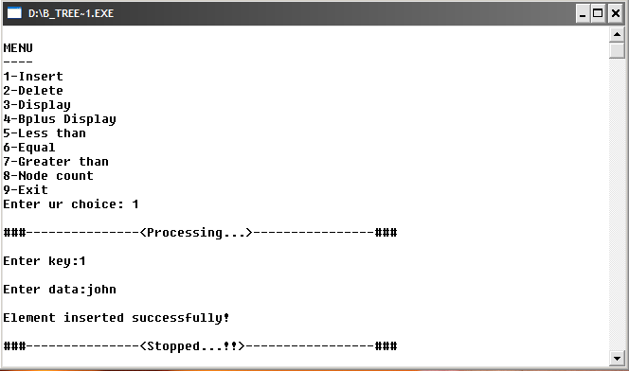

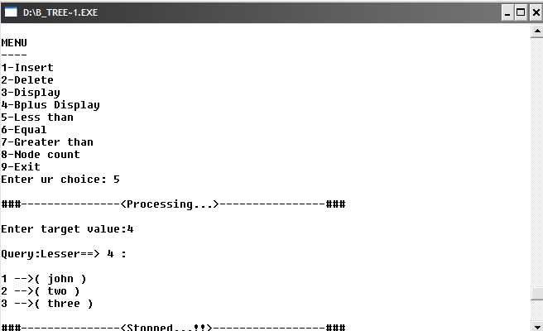

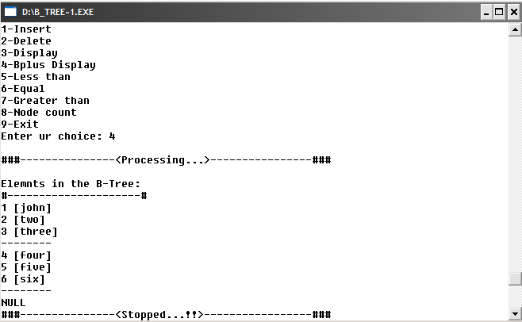

We successfully designed a B+ Tree data structure with all the required operations.
The B+ Trees has the fallowing features
  - It can be capable of holding one million elements
  - It max 32 accesses to fetch an element
  - Queries are possible for =, <, > and for Updating
  - Using Multiprocessing or threading we can speed up the disk accesses

Bibliography:

- Data structures through C-Robert L Cruse,Tondo,Leeung.

- Algorithm design in C++-Sartaj Sahni.

- Introduction to Data structures and Algorithms with C++-Glenn W Rowe.

- Beginning Linux Programming-Neil Matthews and Richard Stones.

- GCC Complete Reference.

